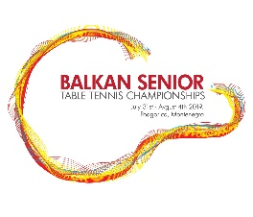 45. BALKAN SENIOR CHAMPIONSHIPS____________
REFEREE TEAM AND LIST OF UMPIRES
REFEREE: MATIJA KRNC (SLO)
DEPUTIES: GORDANA VLASKALIC (SRB)
REJHAN MEMEDOVIC (BIH)
JANA SEKULARAC (MNE)

- LUBISA DOBRASINOVIC (MNE)
- ANJA PEJOVIC (MNE)
- BOZO CORSOVIC (MNE)
- DRAGANA TOMOVIC (MNE)
- ZORAN JANKOVIC (MNE)
- DEJAN SEKULARAC (MNE)
- IVA VUJOVIC (MNE)
- DARKO BARICEVIC (MNE)
- ANDJELKA POPOVIC (MNE)
- BORIS DJUKANOVIC (MNE)
- AZEMI ALBAN (KOS)
- MILE PETRESKI (MKD)
- LACJA BARDHYL (ALB)
- RANKO POPOVIC (SRB)
- MIROSLAV KOSTIC (SRB)

Rezerve: 1. DEJAN BASANOVIC (MNE)

